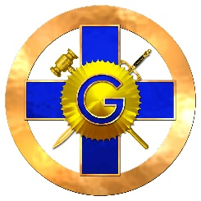
PROCLAMATION
FOR
Leonard E. Stoecker
Eminent Past Prior
WHEREAS: The Supreme Convent General on High has seen fit in his infinite wisdom to call upon Leonard E. Stoecker to lay down his working tools and become a member of his official family on October 9, 2020; and
WHEREAS: Leonard E. Stoecker served his Country and retired with 24 years of military service; and
WHEREAS: Leonard E. Stoecker served his Lodge as Worshipful Master, his Chapter as Excellent High Priest, his Council as Thrice Illustrious Master, his Commandery as Eminent Commander and was chosen to be received as a Knight of the York Cross of Honour; and
WHEREAS: Knight Stoecker served Illinois Priory No. 11 with honor, dignity, and respect for others, and rose to the rank of Eminent Prior; and
WHEREAS: Eminent Past Prior Stoecker has devoted his efforts and energies very diligently on behalf of the Illinois Priory and the Convent General of the United States of America.
NOW, THEREFORE IT IS ORDERED, that this notice be posted on the KYCH-IL website and sent to all members that they receive notice thereof.
Earl F. Wys
Earl F. Wys, KYGCH
Eminent Prior, Attest:
Illinois Priory No. 11 Ronald E. Fullerlove
Ronald E. Fullerlove, PP, KYGCH
Registrar - Illinois Priory No. 11

